


PRESS SWAT Master Protocol Template

How to cite this template SWAT protocol
Bruhn, H., Shiely, F., Parker, A., Wilkinson, J. A., Arundel, C., Sutton, C., … Treweek, S. (2025, March 29). PRESS SWAT Master Protocol Template. Retrieved from https://osf.io/jmpyn/




Item reference | Item heading | Item description | Source
Administrative information
1 | Title | Provide a descriptive title identifying the SWAT study design, SWAT population, interventions, and, if applicable, the SWAT acronym. The term ‘SWAT’ should be used in the title. | 1 SPIRIT  SWAT reporting
2 | Registration | Provide the SWAT identifier and registry name. If not yet registered, name of intended registry. Alternatively, provide the registration details of the SWAT being replicated.  Guidance:  Please use the SWAT specific repository to register your SWAT and/or look for SWATs to replicate: https://www.qub.ac.uk/sites/TheNorthernIrelandNetworkforTrialsMethodologyResearch/SWATSWARInformation/Repositories/SWATStore/ | 2a SPIRIT
3 | Protocol version | Date and version identifier.  Guidance:  For SWAT replications - If significant modification of the protocol is required, consider whether a completely new protocol or new version of the existing protocol is needed. For example, starting the SWAT after the host trial has started (rather than at the same time as the host trial) would require a new version of the protocol. Any changes to the intervention would require a new protocol to be developed. | 3 SPIRIT
4a | Background and why the SWAT is required | Provide a description of the research question and why the SWAT is required, including summary of relevant studies (published and unpublished) examining benefits and harms for each intervention.  Guidance:  We advise to keep the background section ‘light touch’ with a focus on the rationale for the SWAT. | 6a SPIRIT
4b | Comparators | Provide a short explanation for choice of comparator (‘control’) or comparators (‘controls’). | 6b SPIRIT
5 | Objectives | List specific objectives (or hypotheses). | 7 SPIRIT
6 | Design | Give a description of SWAT design including type of SWAT (e.g., parallel group, crossover, factorial, single group), allocation ratio, and framework (e.g., superiority, equivalence, noninferiority, exploratory). | 8 SPIRIT
Methods: Participants, interventions, and outcomes
7 | PPI partner involvement | Are patients and/or public partners involved in any aspects of the SWAT?  Guidance:  For SWAT replications – we recommend consulting PPI partners relevant to your SWAT population and setting if very different from those in the original SWAT.  The GRIPP2 long or short form checklist might be helpful to describe PPI partner involvement. | Cochrane Retention  TFG5
8 | Study setting | Provide a description of SWAT setting(s) (e.g., community clinic, academic hospital). | 9 SPIRIT
9 | Who can take part | Provide details of who can/will take part in the SWAT and reasons why certain groups may not be included. If applicable, eligibility criteria for study centres and individuals who will perform the SWAT interventions (e.g., recruiting staff, Trial Management staff, data Management staff, Trial Monitors etc.).  Guidance:  Please note that from the above description it should be clear whether the SWAT started at the same time as or at a later date than the host trial. It should also be made clear what will be the source of the SWAT sample (e.g., all host trial participants; all host trial participants lost to follow-up; all host trial participants in its control arm; all host trial participants lost to follow-up in the control arm; all host trial participants in the intervention arm; all host trial participants lost to follow-up in the intervention arm). | 10 SPIRIT  (Cochrane Retention)
10a | Interventions | Describe the interventions for each SWAT group with sufficient detail to allow replication, including how and when they will be administered.  Guidance:  The description of each SWAT intervention should include  -Timing  -Mode of Delivery  -Providers  -Co-interventions (existing recruitment/retention/other interventions)  The TIDieR guidance might also be helpful in describing the intervention in sufficient detail. | 11a SPIRIT  Cochrane Retention
10b | Additional interventions that can be used at the same time | List relevant concomitant interventions (existing recruitment/retention/ other interventions) that are permitted or prohibited during the SWAT. | 11d SPIRIT
11 | Outcomes | List primary, secondary, and other outcomes, including how this will be measured (e.g., number returning follow up questionnaires, cost of intervention), analysis metric (e.g., change from baseline, final value, time to event), method of aggregation (e.g., median, proportion), and time point for each outcome.  Note  - All SWATs should include ‘Cost of intervention (Direct costs)’ as a secondary outcome.  - Recruitment SWATs should also evaluate retention (but not delay sharing recruitment results while waiting for retention results).  - Some retention SWATs should evaluate recruitment (e.g., when a retention strategy is advertised in the Participant Information Leaflet).  - Please also provide details of benefits and harms that will be collected/are expected. All important harms or unintended effects in each group that took part in the SWAT (for specific guidance, see CONSORT for harms).  - Also consider and provide details of possible harms to the host trial. | NI SWAT repository  (12 SPIRIT)  (Cochrane Recruitment  Review)  19 SWAT reporting
12 | Economic evaluation details | Provide the following details for the economic evaluation:  -A description of when an economic evaluation will be conducted (an economic evaluation might not be appropriate if the intervention does not show a positive direction of effect)  - Incremental Cost-Effectiveness Ratio (ICER) value or additional cost per participant  -Currency of cost  -Type of economic evaluation  -Health economic perspective adopted | Cochrane Recruitment
13 | Resource | Provide the following details for a resource estimate:  - Staff numbers required to deliver intervention  - Estimated cost of the SWAT (£): [SWAT team to add] | NI SWAT repository  Cochrane retention
14 | Data to be collected and characteristics of SWAT participants | Provide details of the data to be reported for the SWAT or collected additionally for the SWAT if not part of the data collection of the host trial.  Guidance:  SWAT data to be collected should include participant characteristics: age; sex and gender; ethnicity, race or ancestry; socioeconomic status; other characteristics relevant to the study. As a minimum, SWAT teams should be able to describe who is taking part in the SWAT and how representative they are of the host trial population and of the population the host trial is relevant for.  Include a description of the SWAT data collection method (e.g., SWAT data will be collected in the following settings/locations [insert text] using the following methods [e.g., face to face, postal follow- up, telephone follow up, electronic data collection]).  For recruitment SWATs – consider that SWAT participants might not be eligible for the host trial when enrolled in the SWAT although randomisation should ensure equal distribution between SWAT arms. | Cochrane Recruitment/PRO-EDI, PROGRESS+  4b SWAT reporting
15 | Participant timeline | Provide a summary of how participants move through enrolment, interventions, assessments, and visits in the SWAT. A schematic diagram is highly recommended (see example figures in appendix 1) | 13 SPIRIT
Methods: Assignment of interventions (for controlled trials)

16a | Sequence generation | Describe the method to be used to generate the random allocation sequence for the SWAT (e.g., computer-generated random numbers), and list of any factors for stratification. To reduce predictability of a random sequence, details of any planned restriction (e.g., blocking) should be provided in a separate document that is unavailable to those who enrol participants (where relevant) or assign interventions.  Guidance:  The description of the sequence generation should include the level of SWAT randomisation (e.g., Individually randomised; Cluster-randomised). | 16a SPIRIT  8b SWAT reporting  Cochrane Recruitment
16b | Allocation concealment mechanism | Describe the mechanism of implementing the allocation sequence (e.g., central telephone; sequentially numbered, opaque, sealed envelopes), describing any steps to conceal the sequence until interventions are assigned. | 16b SPIRIT
16c | Implementation | Provide details of who will generate the allocation sequence, who will enrol participants (if relevant), and who will assign participants to interventions.  Guidance:  For replication SWATs - This needs to be specified for each individual SWAT conducted but it depends on the host trial as to who implements this so no specific details will be provided in this template protocol. | 16c SPIRIT
17 | Blinding (masking) | If done, describe who will be blinded after assignment to interventions (e.g., SWAT participants, care providers, outcome assessors, data analysts), and how.  Guidance:  For replication SWATs - This needs to be specified for each individual SWAT conducted but it depends on the host trial so we cannot be specific in this template protocol. | 17a SPIRIT
Methods: Data collection, management, and analysis
18 | Data management | Describe plans for data entry, coding, security, and storage, including any related processes to promote data quality (e.g., double data entry; range checks for data values).  Guidance:  It is sufficient to provide ‘light touch’ details. | 19 SPIRIT
19 | Statistical methods | Provide statistical methods for analysing primary and secondary outcomes.  Include  - methods for any additional analyses (e.g., subgroup analyses; adjusted analyses).  - a definition of analysis population relating to protocol non-adherence (e.g., as-randomised analysis), and any statistical methods to handle missing data (e.g., multiple imputation). | 20a SPIRIT  20b SPIRIT  20c SPIRIT
Methods: Monitoring
20 | Interim analysis and stopping rules | Description of any interim analyses and stopping guidelines, including who will have access to these interim results and make the final decision to terminate the SWAT.  Guidance:  Consider together with a statistician whether there is a need for a review point for the SWAT to decide whether one or other trial process alternative is more promising. A progress review will allow the SWAT team to make an informed decision of a non-clinical intervention. This is especially true if the SWAT is being done to actively inform a trial process decision within the host trial, not just for future trials. These details should be decided prospectively and listed in the SWAT protocol. | 21b SPIRIT  TFG5  6b SWAT Reporting
21 | Ethical approval | State plans for seeking research ethics committee/institutional review board approval.  Guidance:  For UK only, include whether overarching HRA approval is needed. | TFG5
22 | Consent or agreement to participate | Will informed consent or assent from potential SWAT participants or authorised surrogates be obtained? Assent is a person’s agreement to take part when the person is unable to provide legal consent, for example because they are underage. An authorised surrogate is someone appointed by the court to represent an individual who lacks capacity to consent.  The description should include  - If informed consent (or assent) will be obtained, who will obtain informed consent or assent from potential SWAT participants or authorised surrogates, and how.  - If informed consent will not be obtained, provide the reason or describe alternative e.g. blanket consent.  Guidance:  See Trial Forge Guidance 5 for further guidance with ethical issues in SWATs. | 26a SPIRIT
23 | How findings will be shared | Describe plans for investigators and Sponsor to communicate SWAT results to participants, healthcare professionals, the public, and other relevant groups (e.g., via direct communication to participants, publication, reporting in results databases, or other data sharing arrangements).  Guidance:  It is sufficient to provide ‘light touch’ details (e.g., simply state that SWAT results will be sent to participants together with the host trial results). | 31a SPIRIT  TFG5  RECAP/HRA
24 | Confidentiality and access to Data | Describe how personal information about potential and enrolled SWAT participants will be collected, shared, and maintained to protect confidentiality before, during, and after the SWAT.  Provide a statement of who will have access to the final SWAT dataset, and disclosure of contractual agreements that limit such access for investigators. Plans, if any, for granting public access to the full SWAT protocol, SWAT participant-level dataset, and statistical code for the analysis in the SWAT.  Guidance:  We suggest that SWAT authors make the data used to generate their results available as a supplementary file, or through data-sharing data sharing platforms such as OSF (https://osf.io). | 27 SPIRIT  29 SPIRIT  31c SPIRIT  SWAT reporting

People to show as the source of this SWAT Master Protocol Template
- Hanne Bruhn, Shaun Treweek, Adwoa Parker, Chris J. Sutton, Catherine Arundel, Jacqueline Wilkinson, Frances Shiely - PRESS project team.

Please share your SWAT findings
If you undertake a SWAT, please share your findings so your results can be included in future updates of the Cochrane systematic review of retention strategies. Please email Dr Adwoa Parker at: swats-group@york.ac.uk

Funding statement
This protocol was developed as part of the PRESS project is funded by the Medical Research Council - National Institute for Health - Research Trial Methodology Research Partnership (MRC-NIHR TMRP) and the Health Research Board Trials Methodology Research Network (HRB-TMRN)] in a joint (HRB-TMRN/MRC-NIHR-TMRP) Working Group Project Seed Co-Funding Award 2023. Adwoa Parker is funded by the National Institute for Health and Care Research (Advanced Fellowship, reference: NIHR302256).
The views expressed are those of the authors and not necessarily those of the NIHR, HRB or the Department of Health and Social Care.

Appendix 1: Two example flow diagrams showing participants movement through a recruitment and retention SWAT

- Example diagram for a recruitment SWAT

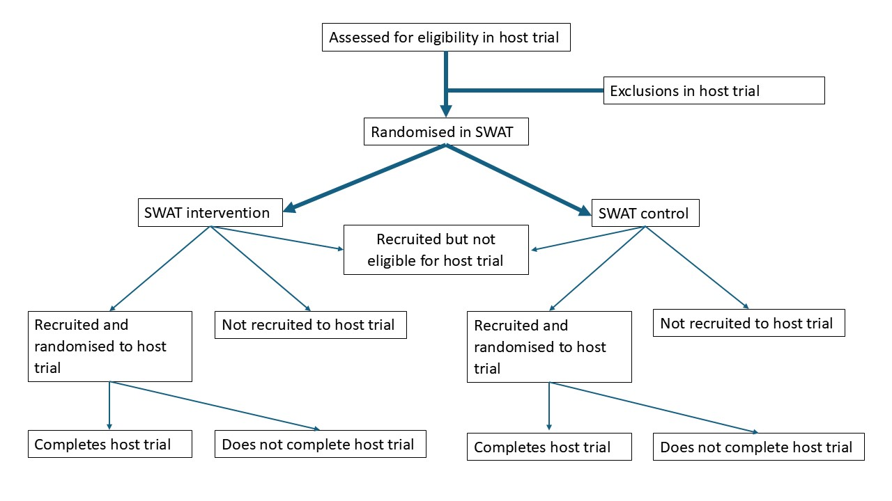
- Example diagram for a retention SWAT

