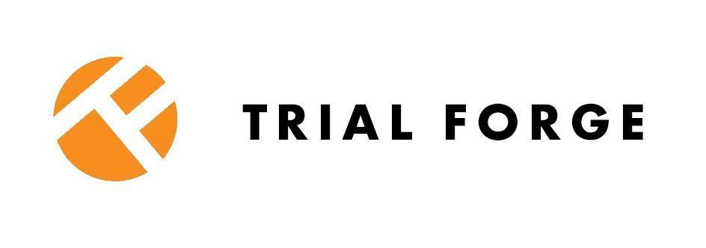


An evaluation of whether monetary incentives increase trial questionnaire return rates (retention) compared to no monetary incentive (MONCENTIVES): template Study Within A Trial protocol

How to cite this template SWAT protocol
Bruhn, H., Treweek, S., Parker, A., Wilkinson, J. A., Sutton, C., Arundel, C., … Shiely, F. (2025, March 30). An evaluation of whether monetary incentives increase trial questionnaire return rates (retention) compared to no monetary incentive (MONCENTIVES): template Study Within A Trial protocol. Retrieved from https://osf.io/t2gnf/files/osfstorage




***Preamble – to be deleted by SWAT team*** |  | Introduction to this SWAT protocol  This protocol has been designed as part of the PRESS project for replication. As this protocol can be used by any SWAT team, in any number of host trials, we are not able to provide a fully completed protocol as we do not know your host trial(s). Hence, you will need to add some details to this protocol in order to tailor it to your host trial and complete the protocol. We’ve highlighted the need to add details in relevant sections entitled ‘how to complete’, text in square brackets can be amended or deleted.  This retention SWAT is intended to start as soon as follow up starts in the host trial. If the SWAT is started later, this protocol needs to be amended accordingly and given a new version and date.  In this SWAT protocol we have used Love2Shop vouchers as an example as they are available as both physical and electronic vouchers in the UK and can be used with a wide range of retailers. We recommend you consult with PPI partners about which type of voucher and value will work best in your SWAT. In our experience, based on consultation with PPI partners, the minimum value should be £10, however due to a large number of ongoing coordinated SWATs testing the effectiveness of £10 voucher incentive vs. no incentive, we encourage you to test other values. Please see Appendix 2 for a list of monetary incentive values and comparators that require further replications.  Consider if this SWAT is right for you - if participants are likely to speak with one another they are likely to talk about having received or not received vouchers. This is likely to cause discontent. This could be more harmful than useful, thus when considering this SWAT, please give the likelihood of trial participants conversing with each other some consideration  This monetary incentive SWAT protocol is an unconditional incentive, paid upfront to participants rather than conditionally on the return of a completed follow-up questionnaire. Both conditional and unconditional SWATs, need evaluation (see Appendix 2) but if you choose to evaluate a conditional incentive in your SWAT, you will need to amend the protocol to reflect this. Appendix 3 provides template cover letter/email/SMS message wording.  This protocol should be used in conjunction with the following documents:  - PRESS SWAT Master Protocol Template  - PRESS Guidance for Researchers Applying for Funding to Conduct High-Priority SWATs of Recruitment and Retention Strategies  - PRESS Randomised Retention SWAT Master Statistical Analysis Plan Template  - PRESS Health Economics Guidance for SWATs of Recruitment and Retention Strategies  - PRESS Guidance on applying for ethical approval for the MONCENTIVES SWAT  ***This document has been prepared using a table so choose ‘all borders’ in Paragraph menu before completing it.***
Administrative information
1 | Title
 | An evaluation of whether monetary incentives increase trial questionnaire return rates (retention) compared to no monetary incentive (MONCENTIVES): Study Within A Trial protocol
2 | Registration
 | SWAT registration on Northern Ireland SWAT repository pending.
3 | Protocol version
30th March 2025, Version 1.0
Guidance:
If modification of the protocol is required, consider if a completely new protocol or new version of the existing protocol is needed.

4a | Background and why the SWAT is required
The SWAT question ‘What is the most effective way to use monetary incentives to support retention?’ was selected by the Trial Forge SWAT Network and the NIHR-funded Implement SWATs programme working group as a priority retention strategy for evaluation¹. To answer the SWAT question, this SWAT study was chosen by three patient and public partners as part of the PRESS project².

Rationale for this intervention
In addition to the above, this strategy has been identified as high priority for evaluation in PRIORITY II (Question 4 and 19). ^{1,3} Monetary incentives are often used as a strategy to support retention in trials. Monetary incentives may increase retention, but the evidence certainty is currently Low (measured by GRADE) so further evaluation is needed.⁴ Previous studies suggest that offering incentives, especially unconditionally, i.e., giving participants the incentive without requiring them to complete a task first, might help to increase retention rates⁴. There is moderate-certainty evidence that monetary incentives may be cost-effective and therefore further evaluation is worthwhile.

Research question
Do monetary incentives increase retention compared to no monetary incentive?

4b | Comparators
 | Monetary incentives are often used to support retention. No monetary incentive can be viewed as ‘usual care’ and is therefore the comparator.
5 | Objective
 | To evaluate the effectiveness and cost-effectiveness of monetary incentives on participant retention in the host trial.
6 | Design
 | The SWAT design is parallel group, with allocation ratio of 1:1, using a superiority framework.
Methods: Participants, interventions, and outcomes
7 | PPI partner involvement
How to complete:
There has been PPI involvement in selection of this SWAT for evaluation. Patient and public involvement partners were asked to rank suggested SWATs for each of 11 SWAT questions, including this one¹. SWATs ranked first were taken forward if PPI partners agreed on the ranking while disagreements were discussed until agreement was reached. [Add further details as per your SWAT patient and public involvement].

8 | Study setting
How to complete:
Describe the setting(s) relevant to your SWAT.

9 | Who can take part
 | All host trial participants actively participating in the study and due a follow-up questionnaire are eligible to be randomised in this SWAT.
10a | Interventions
How to complete:
Intervention: Include a gift voucher (or gift voucher redemption code) along with the initial follow-up questionnaire.
Control: No voucher included with the initial follow-up questionnaire.
Ideally the timing of this SWAT is for follow-up when collecting the primary outcome in the host trial. However, if this is not feasible, or is not the most useful timepoint for the host trial, other follow-up timepoints could be used. The mode of delivery of the intervention should correspond to the mode of the follow up questionnaire. The providers are whoever sends the follow-up questionnaires (e.g. trial office staff or site staff). [The SWAT team should list any relevant co-interventions, e.g., newsletters].
10b | Additional interventions that can be used at the same time
How to complete:
There are no limitations on permitted or prohibited concomitant interventions/recruitment or retention strategies in this SWAT, though any additional recruitment and/or retention strategies used need to be administered to all SWAT arms (i.e. no further randomised comparisons are permitted).

11 | Outcomes
Primary outcome:
Retention rate, defined as the proportion of SWAT participants in each group (voucher vs. no voucher) who return the completed follow-up questionnaire.

Secondary outcomes:
- Unit costs, defined as the costs incurred for each participant within the SWAT. If the effect of the intervention is positive the cost-effectiveness outcome will be reported as the incremental cost per additional participant retained [please see section 12 below and Health Economics Guidance for Undertaking Randomised SWATs of Recruitment and Retention Strategies].
- Number of reminders sent to participants before completion of follow-up questionnaire.
- Time to return of completed follow-up questionnaire.
- Harms or unintended effects to be collected in terms of number of participants who provide feedback and a short description of any feedback from participants in relation to receiving or the lack of monetary incentives.

12 | Economic evaluation details
How to complete:
[The SWAT team should complete this section if appropriate as per Health Economics Guidance for Undertaking Randomised SWATs of Recruitment and Retention Strategies. We encourage SWAT teams to report the costs of the SWAT, even if a full economic evaluation is not undertaken. Please report both direct and indirect costs associated with the intervention. Please see Table below and Health Economic Guidance for a list of direct and indirect costs associated with this SWAT. In addition, relevant costs for the comparator intervention, should also be reported. To estimate the unit costs of monetary incentive vs. usual no monetary incentive, SWAT teams should estimate the total costs for each cost component, then aggregate all relevant components for each intervention and divide them by the number of participants allocated to each intervention group.

Where relevant, the cost-effectiveness outcome should be reported as the incremental cost per additional participant retained (if the effect of the intervention is positive), calculated as:
- Incremental cost per additional participant retained = (unit cost of monetary incentive - unit cost of no monetary incentive)/ (retention rate in monetary incentive group - retention rate in no monetary incentive group).
Where a full economic evaluation is undertaken, we recommend that this adopts the trial team’s perspective (i.e., the reported effects and costs of the intervention will be direct and associated with the trial teams’ budget)].
Example costs to report:
Intervention development |  | Task | Time | Total
 | Patient and public partners involvement  Payment per NIHR guidance:  https://www.nihr.ac.uk/payment-guidance-researchers-and-professionals | Review and feedback type of voucher and value. Also feedback on statement on voucher in questionnaire cover letter if relevant. | 1 hour | [=£25 x number of PPI partners]
Intervention delivery |  | Unit cost
 | Cost of vouchers (intervention and control groups) | Number of vouchers to be sent | N/A | [=cost of one voucher x numbers needed]
 | Postage (if sending vouchers postally) | Number and value of postage |  | [=postage x number to be sent]
Total |  |  |  | [TOTAL COST]

13 | Resource
How to complete:
Moderate.
[The SWAT team should add necessary details as per Health Economics Guidance for Undertaking Randomised SWATs of Recruitment and Retention Strategies. Please see Table above in section 12 for example costs to report. The bulk of the cost is likely to be the monetary incentives themselves. The development of the intervention can add to the cost depending on the e.g. Patient and Public Involvement partners’ involvement in choosing payment amounts and payment types. No additional staff should be needed to deliver this SWAT, but additional time will be needed to obtain the incentive and direct it to the relevant participant and add the voucher/cash with the questionnaire. The SWAT team should add necessary details as per the PRESS SWAT Master Protocol Template].

14 | Data to be collected and characteristics of SWAT participants
Data relating to SWAT allocation and whether the final follow-up was completed will be collected for the SWAT. [All other data are collected as part of the host trial]. The following data will be collected in addition: [insert relevant data as per PRESS SWAT Master Protocol Template].
[While participant characteristics might not be available pre-trial consent, the SWAT team should be able to describe who is taking part in the SWAT and in the host trial in relation to how representative they are of the population the trial is relevant for, at a minimum in terms of sex and gender, age, and ethnicity].

15 | Participant timeline
 | Please see the flow diagram in appendix 1, showing participants’ movement through the SWAT.
Methods: Assignment of interventions (for controlled trials)
16a | Sequence generation
Individual randomisation.
[The SWAT team should complete this section as appropriate as per PRESS SWAT Master Protocol Template and PRESS Randomised Retention SWAT Master Statistical Analysis Plan Template].

16b | Allocation concealment mechanism
How to complete:
[The SWAT team should complete this section as appropriate as per PRESS SWAT Master Protocol Template].

16c | Implementation
How to complete:
[The SWAT team should complete this section as appropriate as per PRESS SWAT Master Protocol Template].

17 | Blinding (masking)
How to complete:
[The SWAT team should complete this section as appropriate as per PRESS SWAT Master Protocol Template and PRESS Randomised Retention SWAT Master Statistical Analysis Plan Template. Describe who will and won’t be blinded after the assignment of participants to the intervention (e.g., researchers, data analysts), and, if blinded, how this will be achieved].

Methods: Data collection, management, and analysis
18 | Data management
How to complete:
[The SWAT team should complete this section as appropriate as per PRESS SWAT Master Protocol Template. Describe plans for data entry, coding, security, and storage, including any related processes to promote data quality (e.g., double data entry; range checks for data values)].
Guidance: It is sufficient to provide ‘light touch’ details.
19 | Statistical methods
[Please refer to Retention SWAT Master Statistical Analysis Plan Template and Health Economics Guidance for Undertaking Randomised SWATs of Recruitment and Retention Strategies].
The primary analysis is the difference in retention rate (returning a completed questionnaire or not for the relevant follow-up timepoint(s)) between those sent a voucher and those not sent a voucher.
[An ‘intention-to-treat’ analysis should be performed. All statistical analyses should be conducted using appropriate software. For the primary outcome analysis, comparison of the response rate between the two SWAT groups should use logistic regression. The between-groups difference should be presented as number (%) and as both adjusted absolute (i.e., risk difference) and relative (i.e., odds ratio or relative risk) effect estimates, with 95% confidence intervals from the logistic regression model. Demographic characteristics, including age and ethnic group should be presented descriptively as mean (standard deviation) or number (%), as appropriate.

For secondary outcomes:
- Costs: All relevant costs associated with each intervention should be aggregated to estimate the average cost per participant in each SWAT group. Unit costs - both direct and indirect - should be presented, including costs of the vouchers. These unit costs should be reported in the currency of the relevant country of the SWAT team and adjusted to current price levels, with any necessary inflation adjustments made. The cost-effectiveness outcome should be reported as the incremental cost per additional participant retained (if the effect of the intervention is positive). This should be calculated by dividing the difference in unit costs between the intervention and comparator groups by the percentage point difference in retention rates between these groups.
- The number of follow-up reminders/calls required should be compared using a Poisson regression model, or a zero-inflated Poisson regression model if there is a large quantity of zeros. The host trial allocation and any stratification variables that were used in the SWAT randomisation algorithm should be included as a covariate.
- Time to return of completed follow-up questionnaire: The between-groups difference in time taken to collection of outcome data will be analysed using a Cox regression model (adjusted for SWAT stratification factors).
- Harms or unintended effects: should be reported descriptively in terms of any feedback from participants in relation to the monetary incentive they have received, such as number of participants who have provided feedback and a short description of the feedback, as negative or positive.
Methods: Monitoring
20 | Interim analysis and stopping rules
How to complete:
[The SWAT team should complete this section as appropriate as per PRESS SWAT Master Protocol Template. Describe any interim analyses and stopping guidelines, including who will have access to these interim results and make the final decision to terminate the SWAT].

21 | Ethical approval
How to complete:
[Please refer to PRESS Guidance on applying for ethical approval for the MONCENTIVES SWAT. Describe the requirements for ethical approval in your jurisdiction. In the UK there are two options for submitting this SWAT for ethics review. The SWAT can be submitted either together with the host trial or as an amendment to the host trial application. This may however vary outside of the UK. Ethical approval is needed as the incentives will be sent to trial participants. The SWAT team should add details as to which option suits their SWAT and host trial.

22 | Consent or agreement to participate
Due to the nature of the monetary incentive SWAT, informed consent will not be obtained, as the SWAT is conducted as part of the host trial follow up process and knowledge of the SWAT might change how potential participants interact with the SWAT intervention. However, we do not consider this to be a major ethical issue as this is a low-risk study. In this case of evaluating whether a monetary incentive impacts on retention rates, seeking individual patient consent prior to sending the monetary incentive is not appropriate as it may confuse participants as to what they are consenting to. It might also impact on their behaviour if they are aware that different retention strategies are being tested, which may adversely affect the integrity of the SWAT evaluation.

Participants randomised to receive vouchers may wish to return vouchers, in which case they will be able to do so. At the end of the [host trial/SWAT], participants will be fully debriefed about the SWAT at the time when the results are shared and for fairness, the control group will receive the same voucher as the intervention group.

23 | How findings will be shared
How to complete:
[The SWAT team should complete this section as per PRESS SWAT Master Protocol Template. We encourage SWAT teams to publish the findings of their SWAT using Trial Forge Guidance 4: a guideline for reporting the results of randomised Studies Within A Trial (SWATs)].

If you undertake this SWAT, please share your findings so your results can be included in future updates of the Cochrane systematic review of recruitment strategies. Please email Dr Adwoa Parker at: swats-group@york.ac.uk].

24 | Confidentiality and access to Data
How to complete:

[The SWAT team should complete this section as appropriate as per PRESS SWAT Master Protocol Template].

People to show as the source of this SWAT idea
- Hanne Bruhn, Shaun Treweek, Adwoa Parker, Chris J. Sutton, Catherine Arundel, Jacqueline Wilkinson, Frances Shiely - PRESS project team.

Please share your SWAT findings
If you undertake this SWAT, please share your findings so your results can be included in future updates of the Cochrane systematic review of retention strategies. Please email Dr Adwoa Parker at: swats-group@york.ac.uk

Funding statement
This protocol was developed as part of the PRESS project is funded by the Medical Research Council - National Institute for Health - Research Trial Methodology Research Partnership (MRC-NIHR TMRP) and the Health Research Board Trials Methodology Research Network (HRB-TMRN)] in a joint (HRB-TMRN/MRC-NIHR-TMRP) Working Group Project Seed Co-Funding Award 2023. Adwoa Parker is funded by the National Institute for Health and Care Research (Advanced Fellowship, reference: NIHR302256).
The views expressed are those of the authors and not necessarily those of the NIHR, HRB or the Department of Health and Social Care.

References
- Parker, A., Way, R., Okanlawon, A. A., Mongelli, G., Coleman, E., Arundel, C., … Treweek, S. WP1: Identifying and prioritising trial recruitment and retention strategies. (2024, February 8). https://doi.org/10.17605/OSF.IO/CZ829
- Parker, A., Bruhn, H., Wilkinson, J. A., Treweek, S., Arundel, C., Sutton, C., … Shiely, F. (2025, March 4). PRESS. Retrieved from https://osf.io/xfkgP/
- Brunsdon, D., Biesty, L., Brocklehurst, P. et al. What are the most important unanswered research questions in trial retention? A James Lind Alliance Priority Setting Partnership: the PRioRiTy II (Prioritising Retention in Randomised Trials) study. Trials 20, 593 (2019). https://doi.org/10.1186/s13063-019-3687-7
Gillies K, Kearney A, Keenan C, Treweek S, Hudson J, Brueton VC, Conway T, Hunter A, Murphy L, Carr PJ, Rait G, Manson P, Aceves-Martins M. Strategies to improve retention in randomised trials. Cochrane Database of Systematic Reviews 2021, Issue 3. Art. No.: MR000032. DOI: 10.1002/14651858.MR000032.pub3. Accessed 08 January 2025.

Appendix 1: Flow diagram showing participants’ flow through the MONCENTIVES SWAT.

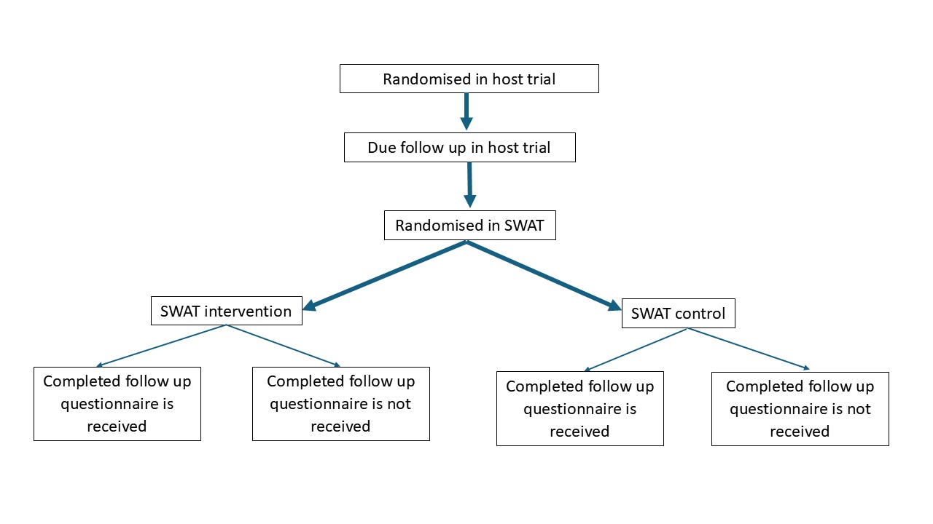

Appendix 2: List of monetary incentive SWAT comparisons
Tables 1 to 3 below provide the monetary incentive values and comparators that have been used in published or ongoing SWATs testing whether monetary incentives increase trial retention. Please note, some SWAT comparisons do not require further replications as there are multiple ongoing SWATs being undertaken. Where this is the case, we have greyed out the relevant row and added **NO FURTHER SWATS NEEDED **.
Table 1: List of unconditional monetary incentive SWAT values and comparators, from Cochrane systematic review of retention strategies (2023)

Comparisons | Monetary incentive value in original currency and format | Currency equivalent when converted | Host trials that tested this SWAT
Intervention: unconditional gift voucher incentive  comparator: no incentive | £5 gift voucher  Kenyon (2005): ‘£5 voucher redeemable at many high street stores’  Gates (2009): £5 Love2Shop voucher | Kenyon (2005)  US$7.12 / EUR€8.16  (Value equivalent exchange rate calculated on 1st April 2002, when voucher first sent FXTOP)  Gates (2009)  US$9.91 / EUR€6.74  (Value equivalent exchange rate calculated on 1st January 2008, when voucher sent FXTOP) | - Kenyon (2005)  - Gates (2009)
Intervention 1: unconditional cash incentive  Intervention 2: unconditional cash incentive  comparator: no incentive | Intervention 1: US$10 cash  Intervention 2: US$2 cash | Intervention 1: US$10 cash  GBP£5.34 / EUR€7.73  Intervention 2: US$2 cash  GBP£1.07 / EUR€1.54  (Value equivalent exchange rates calculated on 1st January 1988, when vouchers first sent FXTOP) | - Bauer (2004)

Table 2: List of unconditional monetary incentive SWAT values and comparators, from SWATs being undertaken as part of the Implement SWATs programme

Comparisons | Monetary incentive intervention value in original currency (format) | Currency equivalent when converted | Host trials testing this SWAT in the Implement SWATs programme (trial registration)
Intervention: unconditional gift voucher incentive  comparator: no incentive  **NO FURTHER SWATS NEEDED ** | GBP£10 (Love2Shop or One4All gift voucher) | USD$12.91  EUR€11.91  (conversion date, 9th March 2025) | - BigTOE (ISRCTN81014195)  - DRAFT3-CASP (ISRCTN66692543)  - MANTRA (NCT05964140)  - OPAL (ISRCTN13694911)  - ReSTORe (ISRCTN81848233)  - ROBUST trial (ISRCTN68282588)  - SPELL trial (ISRCTN15808719)  - The PERISCOPE trial (ISRCTN:17691638)
Intervention: unconditional gift voucher incentive  Comparator: no incentive | EURO€25 (One4All gift voucher) | GBP£20.97  US$27.08  (conversion date, 9th March 2025) | - ComEx Pain feasibility trial (NCT06535633)
Intervention 1: unconditional cash incentive  comparator: no incentive | GBP£10 cash | US$12.91  EUR€11.91  (conversion date, 9th March 2025) | - OPAL (ISRCTN13694911)  - The PERISCOPE trial (ISRCTN:17691638)
Intervention: unconditional cash incentive  comparator: unconditional voucher incentive | Intervention: GBP£10 cash  Comparator: GBP£10 (Love2Shop gift voucher) | US$12.91  EUR€11.91  (conversion date, 9th March 2025) | - The PERISCOPE trial (ISRCTN:17691638)
Intervention: unconditional cash incentive  comparator: unconditional voucher incentive | Intervention: GBP£25 cash  Comparator: GBP£25 (Love2Shop gift voucher) | US$32.28  EUR€29.78  (conversion date, 9th March 2025) | - The Hamlet Trial
Intervention 1: unconditional voucher incentive given at 2 follow-up time points  comparator: unconditional voucher incentive given at one follow-up time point only | GBP£10 (Love2Shop gift voucher) | US$12.91  EUR€11.91  (conversion date, 9th March 2025) | - BigTOE (ISRCTN81014195)  - DRAFT3-CASP (ISRCTN66692543)  - MANTRA (NCT05964140)  - ROBUST trial (ISRCTN68282588)  - SPELL trial (ISRCTN15808719)

Table 3: List of conditional (monetary reward) SWAT values and comparators, from SWATs being undertaken as part of the Implement SWATs programme

Comparisons | Monetary reward intervention value in original currency (format) | Currency equivalent when converted | Host trials testing this SWAT in the Implement SWATs programme
Intervention: conditional monetary reward  comparator: no reward | Intervention: GBP£10 gift voucher | US$12.91  EUR€11.91  (conversion date, 9th March 2025) | - DRAFT3-CASP (ISRCTN66692543)  - MANTRA (NCT05964140)  - ReSTORe (ISRCTN81848233)
Intervention: conditional monetary reward  comparator: no reward | Intervention: USD$100 gift voucher | GBP£77.46  EUR€92.31  (conversion date, 9th March 2025) | - PEM Trial (NCT06630416).  - Solid Tumour Trial (NCT05733000)
Intervention: unconditional incentive  Comparator: conditional monetary reward  **NO FURTHER SWATS NEEDED ** | Intervention: GBP£10 gift voucher  Comparator: GBP£10 gift voucher | US$12.91  EUR€11.91  (conversion date, 9th March 2025) | - AFLOAT (ISRCTN11309776)  - BigTOE (ISRCTN81014195)  - COAT (ISRCTN27053187)  - CONTRACT 2 (ISRCTN16720026)  - DRAFT3-CASP (ISRCTN66692543)  - GRACE (ISRCTN11667770)  - MANTRA (NCT05964140)  - ReSTORe (ISRCTN81848233)  - StratCare-2
Intervention: unconditional incentive  Comparator: conditional monetary reward | Intervention: GBP£20 gift voucher (Love2Shop)  Comparator: GBP£20 gift voucher (Love2Shop) | EUR€23.82  USD$ 25.82 | - BAY (ISRCTN12315118)

Appendix 3: MONCENTIVE Voucher cover letter, email and text template

SWAT voucher procedure
Participants randomised to receive unconditional vouchers will receive a letter, email, text with either a physical voucher or an online voucher redemption code and instructions together with the follow-up questionnaire. The questionnaire can be in paper or electronic form.

Cover letter and email template for sending online/paper voucher
Dear {patient name}
{Insert voucher amount, e.g., £20} to say thank you for taking part in the {host} study.
Please find {enclosed/attached/the link} your {insert time point} follow-up questionnaire. We would be grateful if you could complete this, as this will help the study and make sure that we can provide the best treatment for patients in the future.
As a thank you for your ongoing participation in the study, we are enclosing in this {letter/email} a {Insert voucher amount, e.g., £20} voucher.
__________________________________________________________________________________
[For electronic vouchers only]
{Insert name of voucher company, e.g., Love2shop} Code:
Value:
Expiry date:
To spend your code simply click {e.g., https://www.love2shoprewards.co.uk/login.php} and enter your {Insert name of voucher company} Code into the box provided and click “Enter”. You can now select how you want to spend your Reward Code value. Simply click on the brand you require and decide whether you want to receive a gift card delivered to your home address, or a retailer digital code which will be delivered to you by email or text message. Should you require further information or assistance please do not hesitate to contact https://www.love2shopdigital.co.uk/hsv-contact.php
We really appreciate your help with this study and thank you for continuing to take part
__________________________________________________________________________________

SMS Text message template for sending online voucher

Hi <insert participant name>, this is <insert researcher name> from the [host] study.
Here is the link to your {insert time point} follow-up questionnaire: {insert link}. We would be grateful if you could complete this. As a thank you for your taking part in the study, here is a {Insert voucher amount, e.g., £20} voucher.
Love2shop Code:
Value:
Expiry date:
To spend your code simply click https://www.love2shoprewards.co.uk/login.php and enter your Love2shop Code into the box provided.

